

Predicting Soybean Grain Yield Using Supervised Machine Learning Models

Student Name
Daniela Gomes Feliciano
Department
DEPARTMENT OF COMPUTER SCIENCE AND DATA ANALYTICS
Student ID
2025091
Submission Deadline Date
26th July 2026

Introduction
Soybean is one of the world's most important agricultural crops because it provides a major source of protein and oil for human consumption, animal feed and industrial applications. Improving soybean productivity is therefore a significant objective for researchers and farmers. As grain yield is influenced by a combination of genetic, environmental and management factors. Traditional statistical methods can identify relationships between variables. But machine learning techniques are increasingly used to capture complex patterns and improve prediction accuracy.
This study applies machine learning to predict soybean grain yield using a dataset containing agronomic characteristics collected from 320 observations across 40 cultivars, two growing seasons and four field repetitions. Grain Yield (GY) is treated as the target variable, while the remaining variables are used as predictors. Three supervised regression models Ridge Regression, Random Forest Regression and Gradient Boosting Regression are developed and evaluated. Hyperparameter tuning is performed using GridSearchCV and model performance is assessed using three logical train-test split strategies with MAE, RMSE and R² evaluation metrics. The objective is to identify the most accurate and robust model for predicting soybean grain yield while comparing the strengths, limitations and practical suitability of each machine learning approach.
Dataset Description
The dataset used in this study contains 320 observations and 11 variables collected from soybean field experiments. The target variable is Grain Yield (GY). The categorical Cultivar variable is converted into numerical form using one-hot encoding. Before model development, the dataset is checked for missing values and explored using descriptive statistics, correlation analysis and visualisations to understand the relationships between the variables.
Machine Learning Rationale
The primary objective of this study is to predict soybean grain yield (GY) from agronomic and experimental variables. Since the dataset contains a known target variable (Grain Yield) for every observation, supervised machine learning is the most appropriate learning approach. Supervised learning uses labelled data to learn the relationship between input features and the target variable, enabling the trained model to make predictions for new observations.
Among supervised learning techniques, regression is the most suitable because Grain Yield is a continuous numerical variable measured in quantitative units. In contrast, classification is designed for predicting categorical outcomes, such as disease presence or crop type and is therefore not appropriate for this dataset. Semi-supervised learning is also unsuitable because it is typically applied when only a small proportion of observations are labelled. In this study, all 320 observations include grain yield measurements, meaning the dataset is fully labelled. Although clustering is an unsupervised learning technique that can group soybean cultivars with similar characteristics, it cannot directly predict grain yield and is therefore not selected as the primary modelling approach.
Three regression algorithms are selected and compared: Ridge Regression, Random Forest Regression and Gradient Boosting Regression. Ridge Regression is chosen as a regularised linear model capable of reducing the effects of multicollinearity among predictor variables while providing an interpretable baseline model. Random Forest Regression is selected because it combines multiple decision trees to model complex, non-linear relationships and is generally robust to noise and outliers. Gradient Boosting Regression is included because it builds trees sequentially with each new tree improving the errors made by previous trees, often resulting in high predictive accuracy.
To improve model performance, GridSearchCV with five-fold cross-validation is used to identify the optimal hyperparameter values for each regression model. Three logical train-test split strategies are random 80/20, random 70/30 and cultivar holdout are employed to evaluate prediction accuracy, model stability and generalisation to unseen cultivars. Model performance is assessed using Mean Absolute Error (MAE), Root Mean Squared Error (RMSE) and the coefficient of determination (R²). Comparing these regression models provides a comprehensive evaluation of their predictive performance, interpretability and suitability for soybean grain yield prediction.
Machine Learning Models
Three supervised regression models are selected to predict soybean grain yield: Ridge Regression, Random Forest Regression and Gradient Boosting Regression. Ridge Regression is used as a regularised linear model to reduce the effects of multicollinearity. Random Forest Regression is chosen for its ability to capture complex, non-linear relationships while Gradient Boosting Regression is included for its strong predictive performance by sequentially improving prediction errors. GridSearchCV with five-fold cross-validation is applied to each model to determine the optimal hyperparameter values and improve prediction accuracy.
Training and Testing Strategy
Model performance is evaluated using three logical train-test split strategies: Random 80/20, Random 70/30 and Cultivar Holdout 80/20. The random splits assessed prediction accuracy using different proportions of training and testing data while the cultivar holdout split evaluated the models' ability to generalise to previously unseen cultivars. Performance is measured using Mean Absolute Error (MAE), Root Mean Squared Error (RMSE) and R² providing a comprehensive comparison of prediction accuracy, model stability and generalisation capability.
Results and Discussion
Three supervised regression models Ridge Regression, Random Forest Regression and Gradient Boosting Regression are evaluated using three train-test split strategies: Random 80/20, Random 70/30 and Cultivar Holdout 80/20. Model performance is assessed using Mean Absolute Error (MAE), Root Mean Squared Error (RMSE) and the coefficient of determination (R²). Lower MAE and RMSE values indicate better prediction accuracy, while higher R² values indicate better model performance.
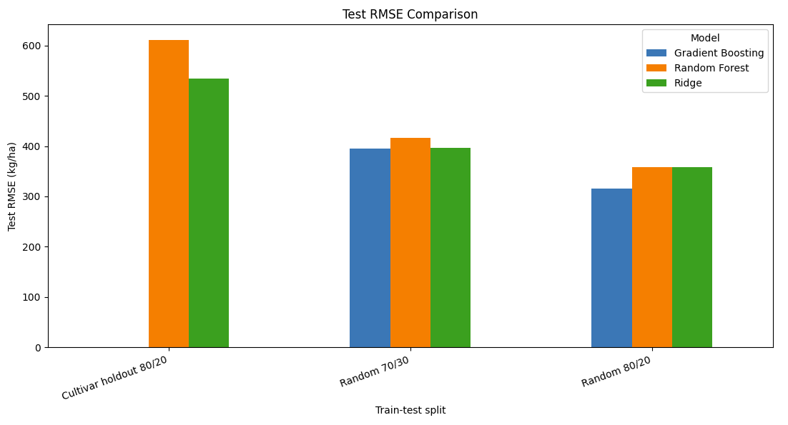
Figure 1 compares the Test RMSE of the three models across the train-test splits. Gradient Boosting consistently produced the lowest prediction error for the Random 80/20 and Random 70/30 splits. However, prediction errors increased for all models under the Cultivar Holdout split, indicating that predicting unseen cultivars is more challenging than predicting cultivars included in the training data.
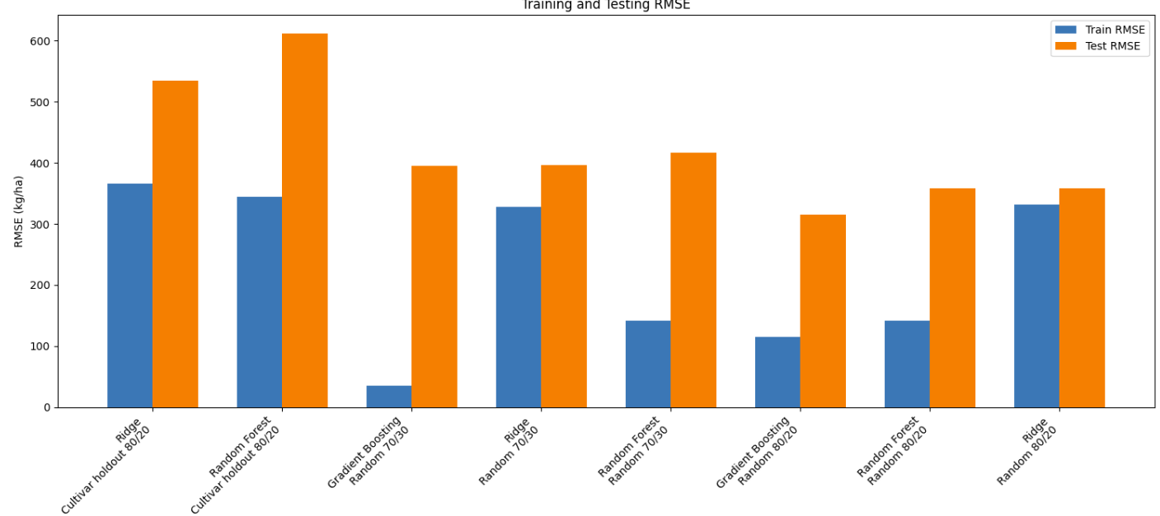
Figure 2 compares the training and testing RMSE values. Gradient Boosting and Random Forest show larger differences between training and testing errors, suggesting some degree of overfitting. In contrast, Ridge Regression has a smaller gap, indicating better stability and lower variance.
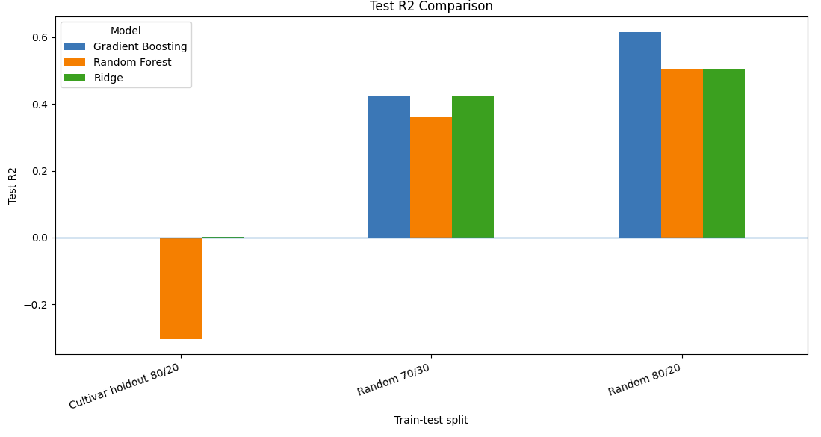
Figure 3 presents the Test R² values. Gradient Boosting achieved the highest R² for both random splits, while Ridge Regression produced comparable results for the Random 70/30 split. Random Forest recorded a negative R² for the Cultivar Holdout split, demonstrating poor generalisation to previously unseen cultivars.
Overall, Gradient Boosting provided the highest prediction accuracy, whereas Ridge Regression demonstrated better stability and generalisation. These results highlight the importance of evaluating models using multiple train-test strategies, particularly cultivar-based holdout testing, to assess their practical performance in soybean yield prediction.
Conclusion
This study demonstrated the application of supervised machine learning techniques to predict soybean grain yield using agronomic data. Three regression models Ridge Regression, Random Forest Regression and Gradient Boosting Regression are evaluated using three train-test split strategies and assessed with MAE, RMSE and R². The results showed that Gradient Boosting achieved the highest prediction accuracy, while Ridge Regression provided more stable and consistent performance across different data splits. The cultivar holdout evaluation highlighted the importance of testing models on unseen cultivars to assess their generalisation capability. Overall, the study shows that machine learning can effectively support soybean yield prediction with Gradient Boosting being the most accurate model for this dataset and Ridge Regression offering a reliable and interpretable alternative.
References
Breiman, L., 2001. Random forests. Machine learning, 45(1), pp.5-32.
Friedman, J.H., 2001. Greedy function approximation: a gradient boosting machine. Annals of statistics, pp.1189-1232.
Hoerl, A.E. and Kennard, R.W., 1970. Ridge regression: Biased estimation for nonorthogonal problems. Technometrics, 12(1), pp.55-67.
Pedregosa, F., Varoquaux, G., Gramfort, A., Michel, V., Thirion, B., Grisel, O., Blondel, M., Prettenhofer, P., Weiss, R., Dubourg, V. and Vanderplas, J., 2011. Scikit-learn: Machine learning in Python. the Journal of machine Learning research, 12, pp.2825-2830.
Iskom, M.L., 2021. Seaborn: statistical data visualization. Journal of open source software, 6(60), p.3021.
Harris, C.R., Millman, K.J., Van Der Walt, S.J., Gommers, R., Virtanen, P., Cournapeau, D., Wieser, E., Taylor, J., Berg, S., Smith, N.J. and Kern, R., 2020. Array programming with NumPy. nature, 585(7825), pp.357-362.

